**Hand Talk**

|  |  |  |  |  |
| --- | --- | --- | --- | --- |
| **Semester: Fall_22_23** | | **Section: H** | **Group Number: TEAM ZERO** | |
| SN | Student Name | Student ID | Contribution (CO1+CO2) | Individual Marks |
| 1 | Shahriar Hannan | 20-43179-1 |  |  |
| 2 | Nazmus Sakib | 20-43156-1 |  |  |
| 3 | Iftikharul Islam Eishat | 20-43183-1 |  |  |
| 4 | Nazmus Sakib | 20-42961-1 |  |  |

# PROJECT PROPOSAL

## Background to the Problem

**Sign Language is mainly used by deaf (hard hearing) and dumb people to exchange information between their own community and with other people. It is a language where people use their hand gestures to communicate as they can’t speak or hear. Sign Language Recognition (SLR) deals with recognizing the hand gestures acquisition and continues till text or speech is generated for corresponding hand gestures.This type of gesture-based language allows people to convey ideas and thoughts easily overcoming the barriers caused by difficulties from hearing issues.**

## Solution to the Problem

**The main objectives of this project are to contribute to the field of automatic sign language recognition and translation to text or speech. In our project, we focus on static sign language hand gestures. This work focused on recognizing the hand gestures which includes 26 English alphabets (A-Z) and 10 digits (0-9).This works focuses on static fingerspelling in American Sign Language A method for implementing a sign language to text/voice conversion system without using handheld gloves and sensors, by capturing the gesture continuously and converting them to voice.**

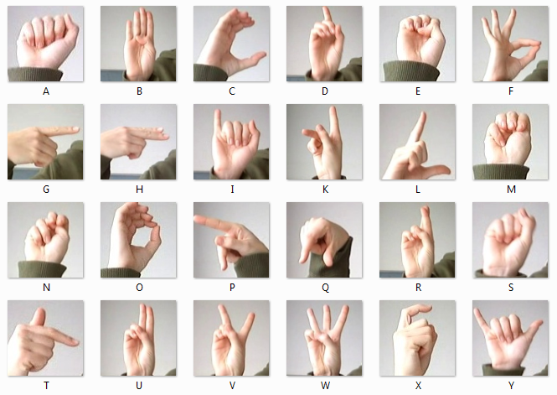

**Functional Requirements:**

• This feature will translate the recognized gesture into the textual meaning of the gesture and display the translated text to the user.

• System will recognize the appropriate movement of the hands and will search its database to match the movement with the pre-defined gestures. After matching system, will add the meaning of the sign to the opened file.

**1.Software Login:** If user have already an account then he simply just log in with user name and password. If not then user need to sign up with appropriate information.

**Priority Level**: High.

**Precondition**: User have valid username or password.

**2.Mode:** After log in user can choose from two options one is COMMUNICATION MODE & another one is LEARNING MODE.

 If user selects communication mode he may have 2 options one is Vedio/Sign & another one is Audio/Text. After that if user is dumb/deaf then he needs to perform sign language for that he needs to selects Vedio/Sign option. Then user performs the movement. Gesture is recognized and has a match. The text is added to the file and displayed to the user and also speech out the words or sentence. If user is normal people he just need to select Audio/Text option to understand the sign language.

 If user wants to learn sign language he have to select the learning mode. Inside the learning mode there are few options available which are ALPHABETS, NUMBERS, COLORS, FOOD, FAMILY.

**Priority Level**: Medium.

**Precondition**: User must have leap motion controller.

**Non-functional Requirements:**

• Performing ISL via Leap motion controller should be used by a single person. Our system should run on 32 bit (x86) or 64 bit (x64) Dual-core 2.66-GHZ or faster processor. It should not exceed 2 GB RAM.

• For the time being, we will use Leap motion controller to control the input stream and C programming language in the Visual Studio. Software architecture will be based on real time continuous gesture recognition methods.

**Project Process Model:**

Scrum would be the best process model for our software development. Large projects are broken into smaller sprints in scrum. Therefore, scrum can contribute in the rapid and effective completion of project outputs. Scrum guarantees efficient time and money management.

The sprint review involves the coding and testing of developments.

Effective for quick development initiatives.

Through scrum meetings, the team has clear visibility.

Scrum incorporates feedback from consumers and stakeholders since it is nimble.

Short sprints make it much simpler to make adjustments in response to feedback.

During daily scrum meetings, each team member's individual effort is evident.

We have the following requirements for the process model:

1. We want to complete our project promptly and effectively.

2. Our project is sign language recognition system .

Customer comfort and usability are therefore our top priorities, and we aim to use their feedback to make our software better.

3. We wish to invest our time and resources in this project wisely.

4.Daily team meetings are essential for a project like this that is just getting started.

We won't be able to use client feedback to improve our product if we take a plan-driven approach. Plan-driven methodologies also take longer than agile methodologies, with scrum being the most appropriate agile methodology for our project.

**Diagram**

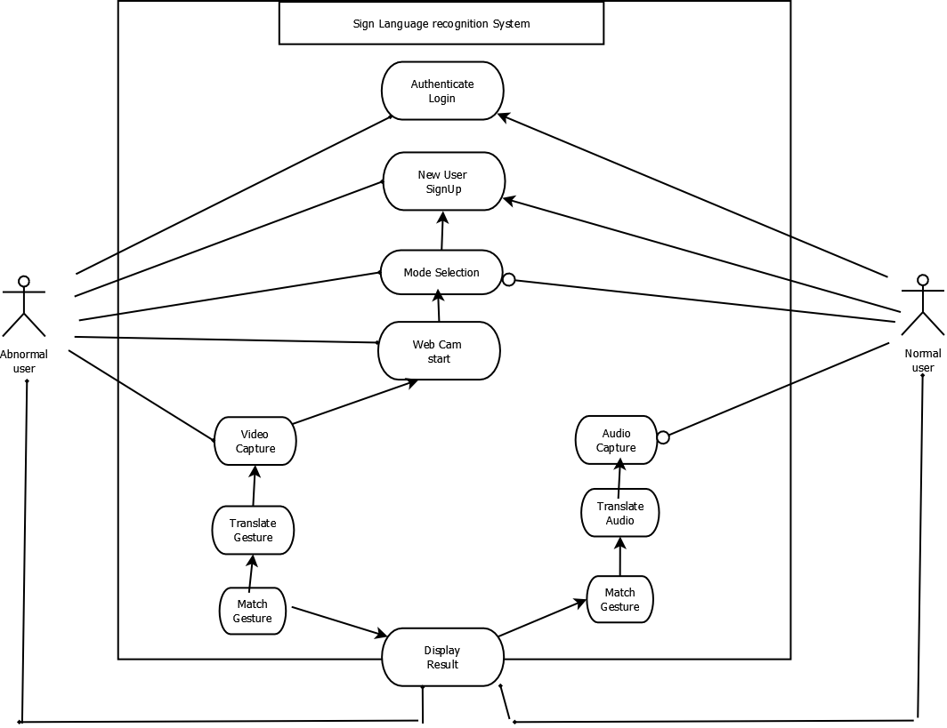

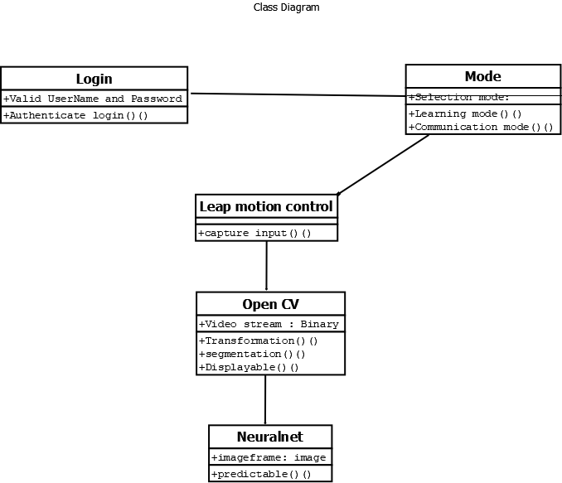

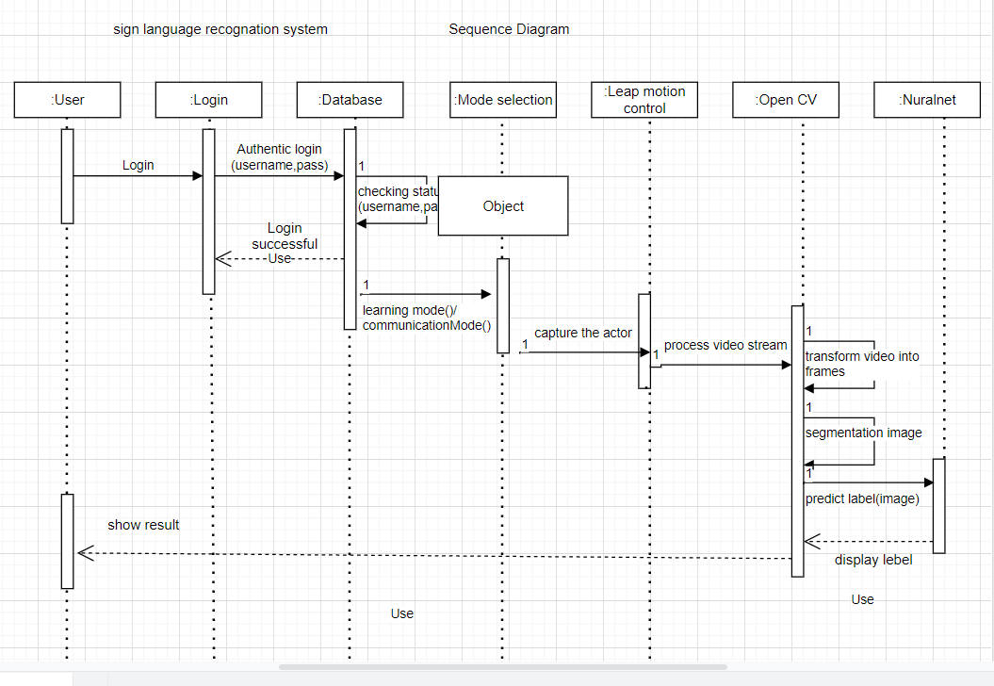

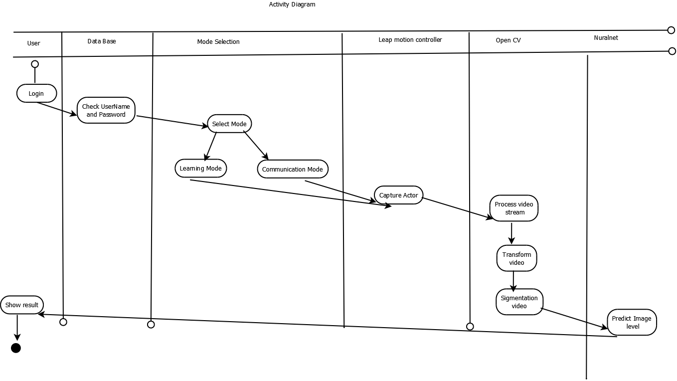

**User Interface**

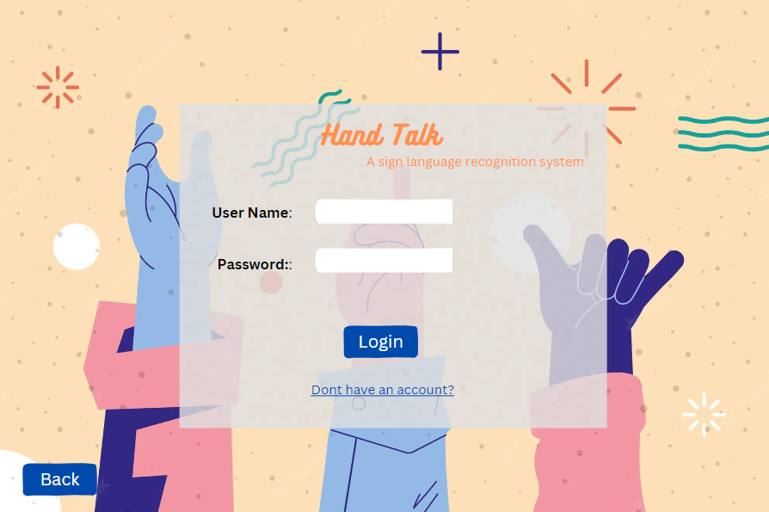

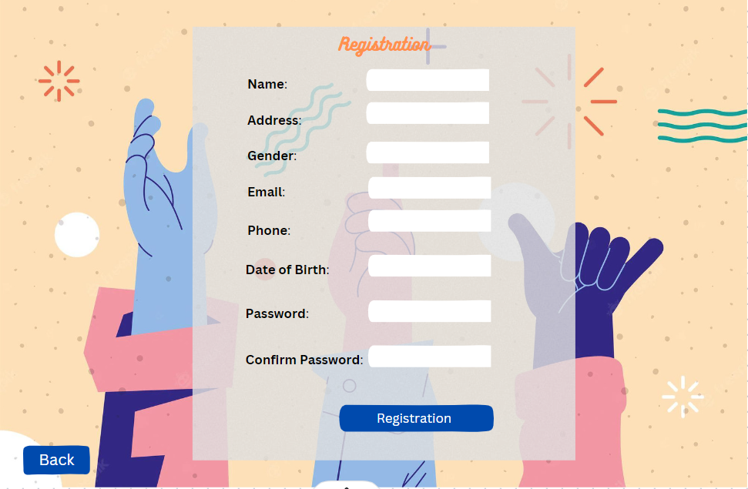

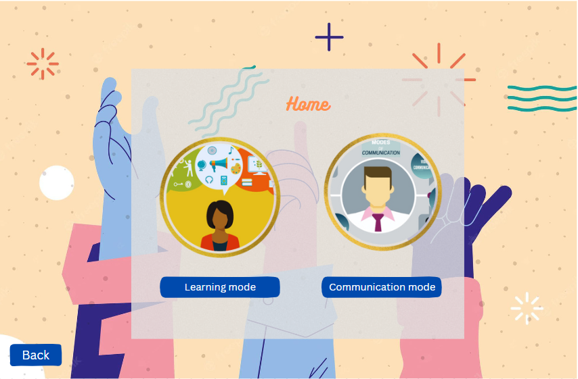

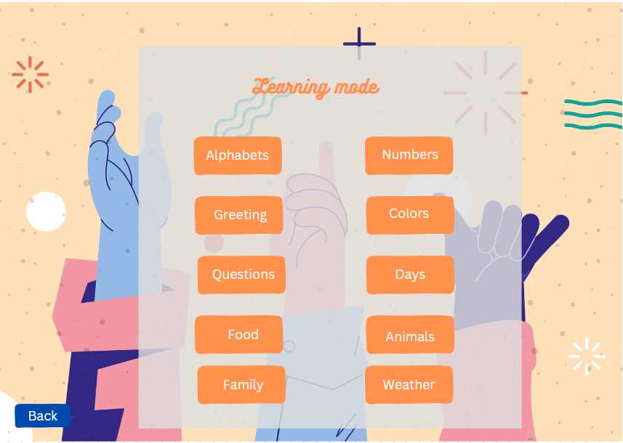

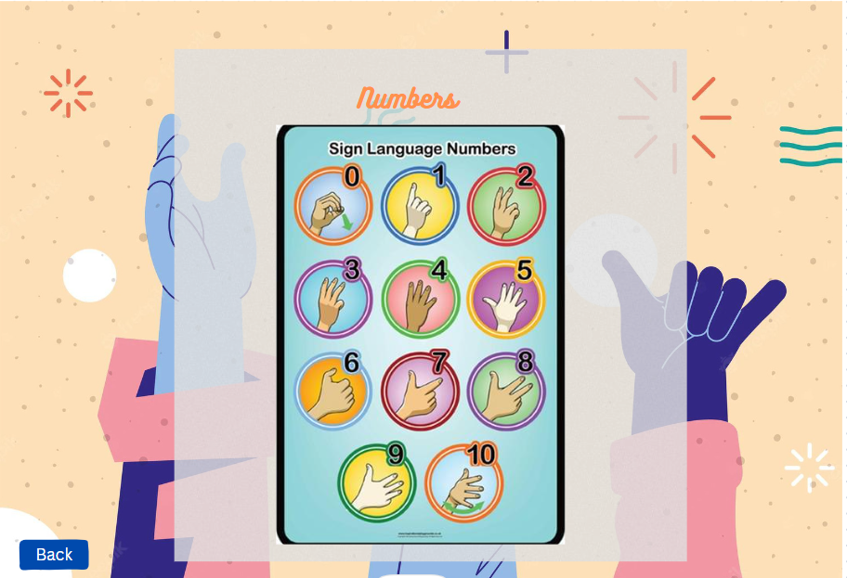

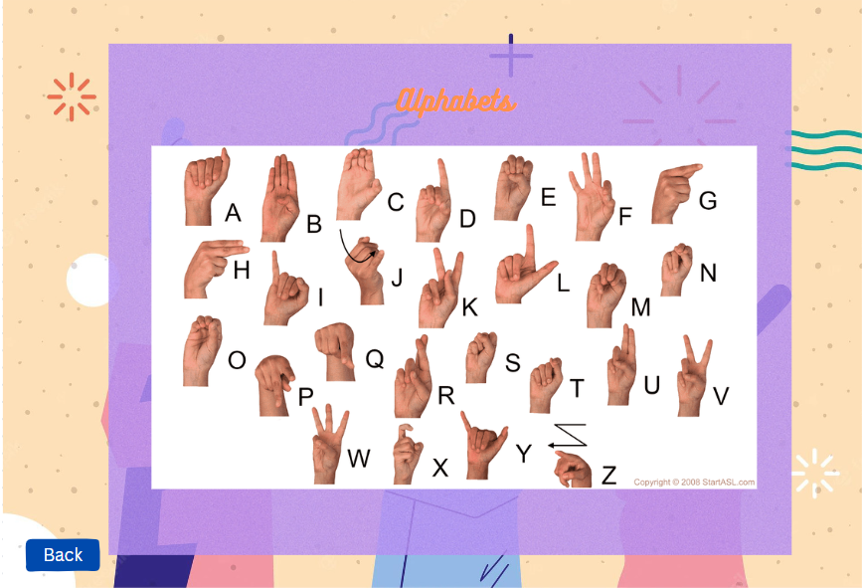

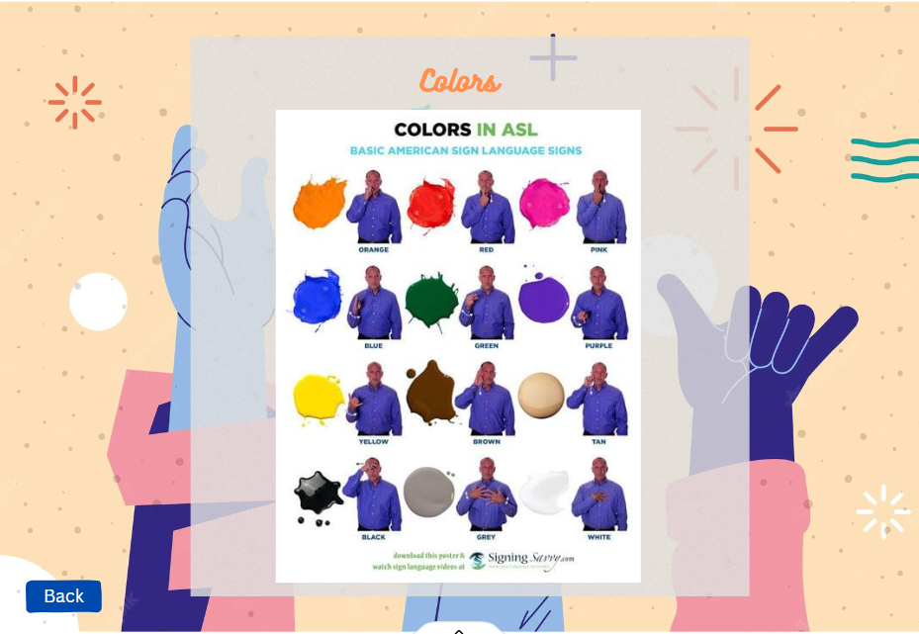

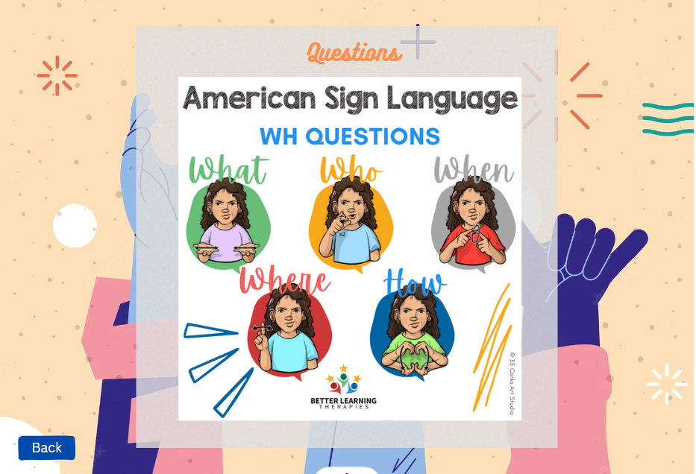

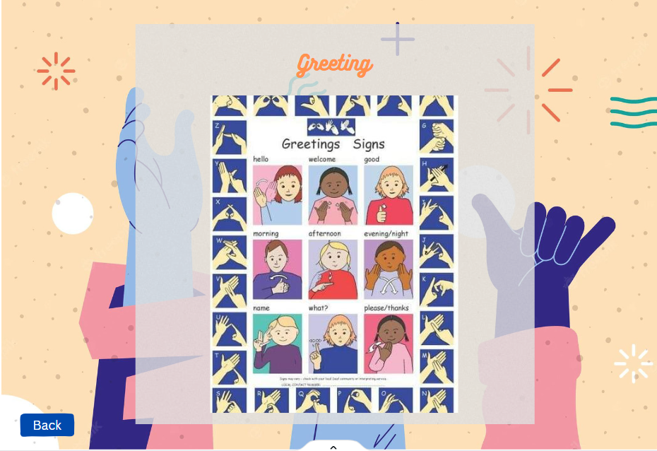

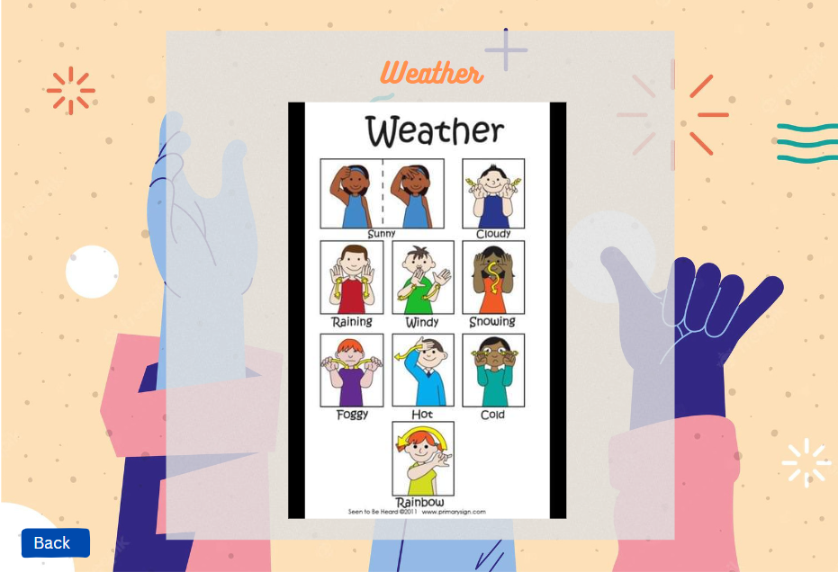

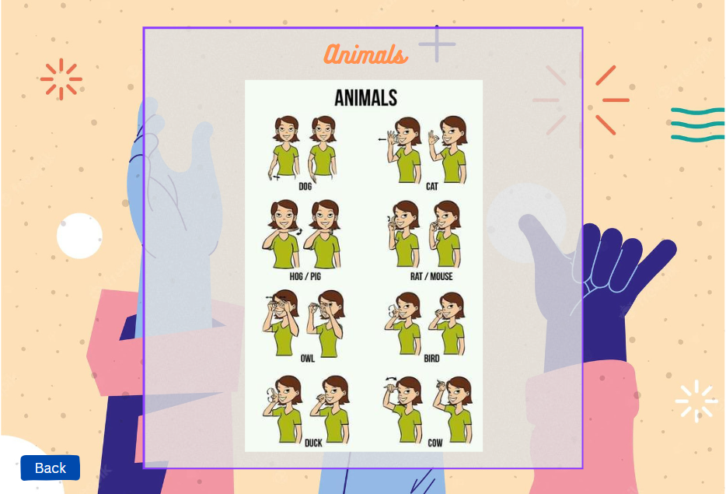

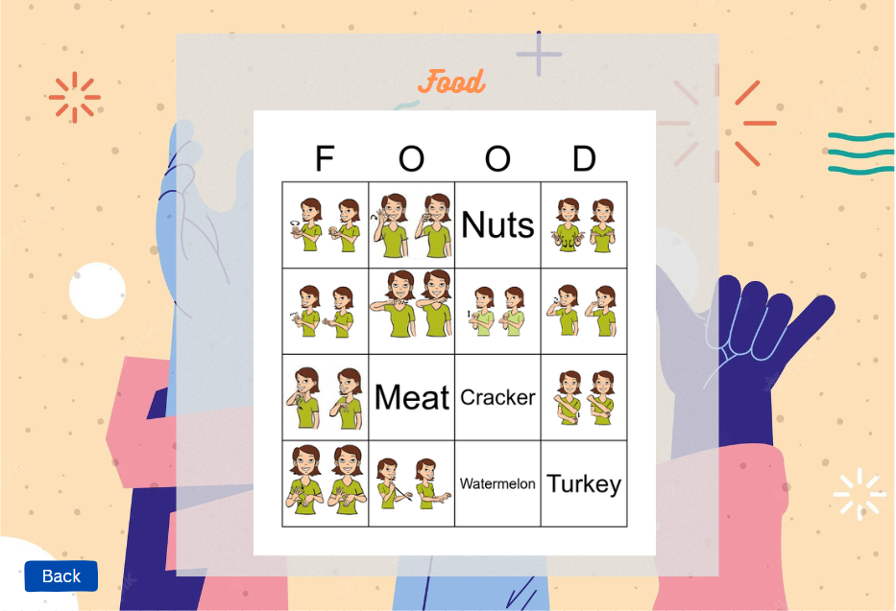

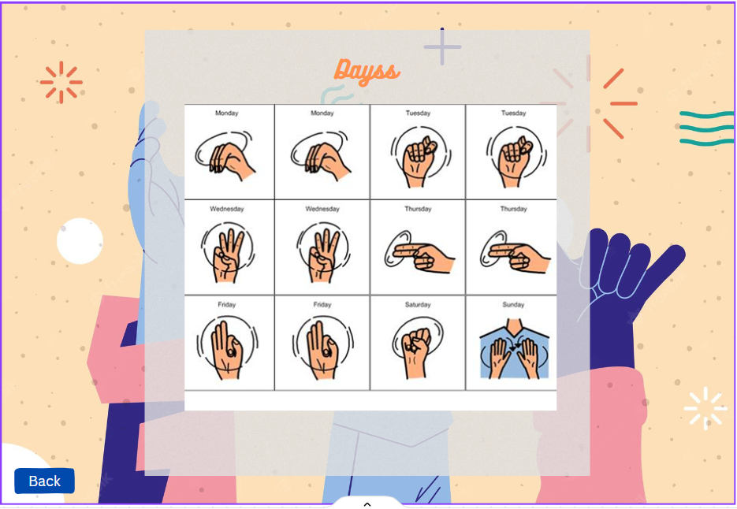

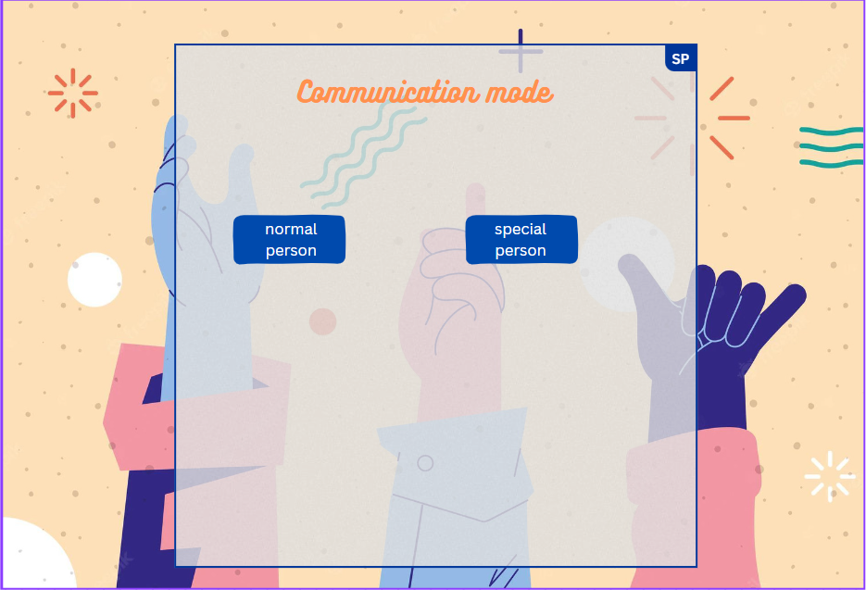

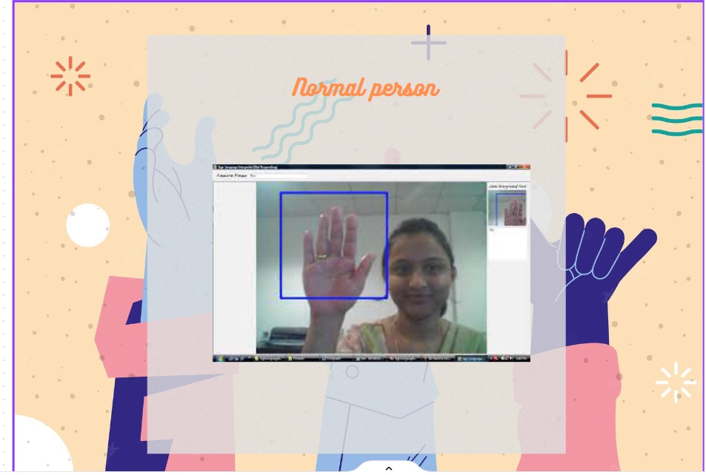

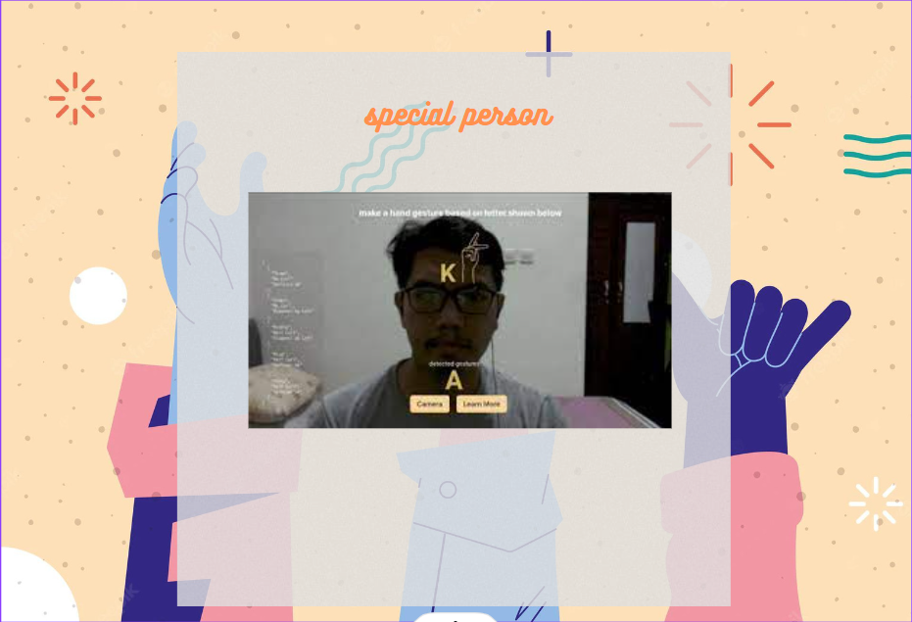

**Test Case:**

A test case is a set of actions performed on a system to determine if it satisfies software requirements and functions correctly. The purpose of a test case is to determine if different features within a system are performing as expected and to confirm that the system satisfies all related standards, guidelines and customer requirements. The process of writing a test case can also help reveal errors or defects within the system.

Test cases, which serve as step-by-step instructions for each system test, are often developed by members of the testing team or the quality assurance (QA) team. Once a system feature or set of features has been finished by the development team, testing can start. A test suite is a series or collection of test cases.

**Bug in Software:**

A software bug is a mistake that causes in a program crashing or producing incorrect output. The issue is brought on by incorrect or insufficient logic. An error, omission, fault or defect that could lead to failure or a deviation from desired results is referred to as a bug.

**Bug Report:**

A bug report is a particular kind of report that details information on what is incorrect and needs to be fixed in software or on a website. The report outlines the causes of any mistakes that were discovered in order to highlight exactly what was deemed to be incorrect. It also contains a request and instructions on how to fix each problem.

**Test Automation**

**1.**

|  |  |  |  |  |
| --- | --- | --- | --- | --- |
| Project Name: **Sign language Recognition System** | | | Test Designed by: **Team 0** | |
| Test Case: A_1 | | | Test Designed date: 11.11.22 | |
| Test Priority (Low, Medium, High): Medium | | | Test Executed by: **Nazmus Sakib(2)** | |
| Module Name: Login Session | | | Test Execution date: 11.12.22 | |
| Test Title: Verify login with valid data. | | | | |
| Description: Test Application login system. | | | | |
| Precondition (If any): User must have valid email address or username and password. | | | | |
| Test Steps | Test Data | Expected Results | Actual Results | Status (Pass/Fail) |
| 1. Go to the home page 2. Go to Login Window 3. Enter username or mail 4. Enter password 5. Click Login Button | Username: test_user10  Password:  User10@123  Email:  User10@gmail.com | User login successfully using valid User name or Email and password | As expected, | Pass |
| Post Condition: User login successfully to given required information. | | | | |

**2.**

|  |  |  |  |  |  |
| --- | --- | --- | --- | --- | --- |
| Project Name: **Sign Language Recognition System** | | | Test Designed by: Team 0 | | |
| Test Case: A_2 | | | Test Designed date: 11.11.22 | | |
| Test Priority (Low, Medium, High): Medium | | | Test Executed by: **Nazmus Sakib(2)** | | |
| Module Name: Registration session | | | Test Execution date: 11.12.22 | | |
| Test Title: Create a new account using required data. | | | | | |
| Description: Test application registration system. | | | | | |
| Precondition (If any): User must enter valid email address, username should be available, password should be a strong password (at least 8 chars, including one at least Uppercase latter and one at least special character) | | | | | |
| Test Steps | Test Data | Expected Results | | Actual Results | Status (Pass/Fail) |
| 1. Go Home Page  2. Go to Registration Window  3. Enter username  4. Enter password  5. Enter Email  6. Enter Address  7. Enter Phone (optional)  8. Verify CAPTCHA  9. Click Registration  10. Enter OTP from email  11. Click on Profile link | Username: test_user10  Password:  User10@123  Email:  [User10@gmail.com](mailto:User10@gmail.com)  Address:  Dhaka, Bangladesh | User data should  be store to the  database, after  click registration  user should get  OTP on his email.  After enter valid  OTP user should  be able to go to his profile. | | As expected, | Pass |
| Post Condition: User is validated with database and successfully created a new account. The account session details are saved in the database. | | | | | |

**3.**

|  |  |  |  |  |  |
| --- | --- | --- | --- | --- | --- |
| Project Name: **Sign Language Recognition System** | | | Test Designed by: Team 0 | | |
| Test Case: A_3 | | | Test Designed date: 25.11.22 | | |
| Test Priority (Low, Medium, High): Medium | | | Test Executed by: **Nazmus Sakib(2)** | | |
| Module Name: Communication Mode Execution Session | | | Test Execution date: 11.12.22 | | |
| Test Title: Camera, Microphone and clear visibility check in specific time. | | | | | |
| Description: Test Application Communication mode check. | | | | | |
| Precondition (If any): User check leap motion sensor , camera and microphone. | | | | | |
| Test Steps | Test Data | Expected Results | | Actual Results | Status (Pass/Fail) |
| 1. Go to the homepage 2. Go to Login 3. Go to communication Mode 4. Give permission on open camera and microphone 5. Click start chating | Performing sign language. | Save all  information in  database and set a notification. | | Unexpected, | Pass |
| Post Condition: User can perform communication mode. | | | | | |

**Bug Report:**

|  |  |
| --- | --- |
| **Bug Name:** Application cannot showing appropriate result on communication mode. | |
| **Bug ID:** (It will be automatically created by the BUG Tracking tool once you save this bug). | |
| **Area Path:** Login àCommunication modeà Start Chatting | |
| **Build Number:** Version Number 2.0.1 | |
| **Severity:** HIGH (High/Medium/Low) or 1 | **Priority:** HIGH (High/Medium/Low) or 1 |
| **Assigned to:** Group-4 members | **Reported By: Nazmus Sakib(2)** |
| **Reason:** Defect | **Reported On:** 11/25/2022 |
| **Status:** New/Open/Active: New | **Environment:** Windows 11/SQL Server 2014 |
| **Description:** Application crashes when detecting human skalaton . | |
| **Steps to Reproduce:**   1. Login into the Application. 2. Go to communication mode 3. Open camera and microphone 4. Start chatting 5. Seen an error page “ Exception: Readed successfully” 6. See the attached logs for more information (Attach more logs related to the bug…IF any) 7. Also see the attached screenshot of the error page. | |
| **Expected Result:** On clicking the start chatting button, you should be prompted to a successful message “Message readed successfully”. | |

**WBS And Effort Estimation:**

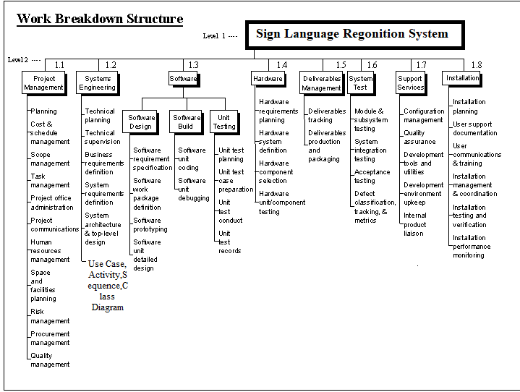

**Source line of code = 10000**

* **Effort = PM = Coefficient<Effort Factor>*(SLOC/1000)^P**

= 2.4 * (10000/1000)^1.05

= 26.928

* **Development time = DM = 2.50*(PM)^T**

= 2.50 * 26.928 ^ 0.38

= 8.738

* **Required number of people = ST = PM/DM**

=26.928/8.738

=3.08

|  |  |  |
| --- | --- | --- |
| Task | Planned Effort | Actual Effort |
| 1 | 12 | 13.5 |
| 2 | 15 | 11 |
| 3 | 13 | 15 |
| 4 | 12.5 | 9 |
| 5 | 9.5 | 10 |
| 6 | 15 | 19.5 |
| 7 | 8 | 11 |
| 8 | 4 | 5 |
| 9 | 12.5 | 11 |
| 10 | 6 | 7.5 |
| 11 | 5 | 5.5 |
| 12 | 12.5 | 13.5 |
| 13 | 13.5 | 9.5 |
| 14 | 6 |  |
| 15 | 8 |  |
| Given total task = 56 | BCWP = 138.5  BCWS = 152.5 | ACWP = 141 |
|  |  |  |

* BAC = 593.00
* SPI = BCWP/ BCWS = 138.5/ 152.5 = 0.9081
* SV = BCWP - BCWS = 138.5 - 152.5 = -14 person-day
* CPI = BCWP/ ACWP = 138.5/141 = 0.9822
* CV = BCWP – ACWP = -3 person-day
* % schedule for completion = BCWS/ BAC = 156.5/ 593.00  
   = 26.39%

[% of work scheduled to be done at this time]

* % complete = BCWP/ BAC = 126.5/ 593.00 = 21.33%  
   [% of work completed at this time]

|  |  |  |  |  |  |  |  |  |  |
| --- | --- | --- | --- | --- | --- | --- | --- | --- | --- |
| * Person/Week | 1 | 2 | 3 | 4 | 5 | 6 | 7 | 8 | 9 |
| A: Fahim |  |  |  |  |  |  |  |  |  |
| B: Fahim |  |  |  |  |  |  |  |  |  |
| C: Fahim |  |  |  |  |  |  |  |  |  |
| D: Eishat |  |  |  |  |  |  |  |  |  |
| E: Piash |  |  |  |  |  |  |  |  |  |
| F: Eishat |  |  |  |  |  |  |  |  |  |
| G: Sakib |  |  |  |  |  |  |  |  |  |

Activity Key:

A: Overall Design

B: Specify module1

C: code module 1

D: Integration Testing 1

D: specify module 2

E: Code Module 2

F: Integration Testing 2

G: System Testing

**Timeline Chart**

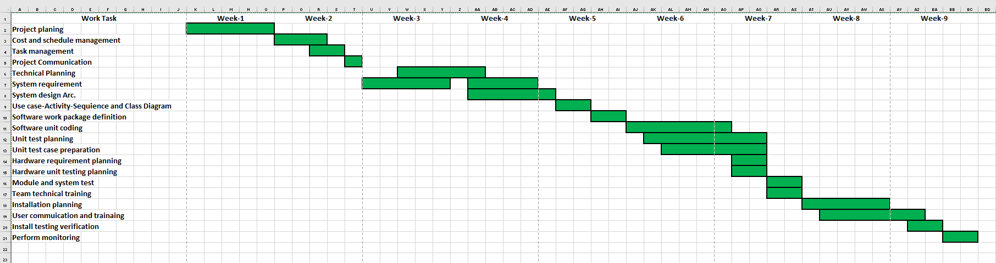

**Risk Management**

|  |  |  |  |  |
| --- | --- | --- | --- | --- |
| Risks | Category | Probability | Impact | RMMM |
| Improper management of task | OR(operational risk) | 20% | 3 |  |
| Loss of contracts due to any reason | PR(programmic risk) | 30% | 3 |  |
| Improper integration of modules | TR(technical risk) | 50% | 2 |  |
| Conflict between task and employees | OR(operational risk) | 30% | 2 |  |
| Changes in Government rules or policy | PR(programmic risk) | 70% | 2 |  |
| Size estimate may be significantly low | PS | 60% | 2 |  |
| Larger number of users than planned | PS | 30% | 3 |  |
| Less reuse than planned | PS | 70% | 2 |  |
| End-users resist system | BU | 40% | 3 |  |
| Delivery deadline will be tightened | BU | 50% | 2 |  |
| Funding will be lost | CU | 40% | 1 |  |
| Customer will change requirements | PS | 80% | 2 |  |
| Technology will not meet expectations | TE | 30% | 1 |  |
| Lack of training on tools | DE | 80% | 3 |  |
| Staff inexperienced | ST | 30% | 2 |  |
| Staff turnover will be high | ST | 60% | 2 |  |